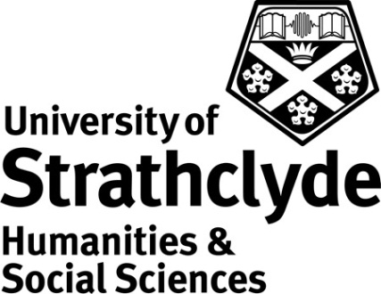

Centre for Lifelong Learning
Taking Acrylic Painting Further 4
Class Code: OS126 (10 credit points)

Rationale

This is the fourth in a series of acrylic painting classes offered within the Applied Arts Pathway of the Open Studies Certificate Programme. It complements class Taking Acrylics Further 3 (OS284). The central aim of the class is to develop and extend the student’s skills by setting a programme of challenging objects in acrylics with the primary aim of further developing personal techniques and extending the range of materials used in painting, including acrylic additives. Different subjects will be tackled to allow opportunity to explore different moods and problems. The class allows the student to choose a personal theme for further development. Peer assessment will be an important element as it will give participants the opportunity to explain and discuss the processes involved in the creation of their work, and thus develop self-assessment and independent learning skills. Students will be encouraged to reflect on, and explore, the theme using as many different types of acrylic technique as possible.

Learning Outcomes
By the end of the class student should be able to:

- Demonstrate competence in the use of additives and application techniques in a variety of subject matter
- Show confident technique through sustained painting projects
- Plan a creative approach to improving personal technique through keeping a reflective diary
- Reflect on their own strengths and weakness in the use of acrylics

Content and Curriculum

Participants are expected to have a good understanding of the principles of acrylic painting as covered in Learn to Paint (Acrylics) (OS119), Taking Your Acrylics Painting Further 1,2 and 3 (OS643, O644 and OS284).

The following represents an overview of the main areas to be covered. It does not necessarily represent the order in which topics will be addressed, nor does it imply that equal time will be devoted to each topic.

- Experimenting with different additives.
- Loosening up
- Creating an individual approach
- Using personal sketches and photographs of different subject matter as a starting point
- Working from life and portrait models
- Individual and paired tutorials to encourage personal development through discussion, reflection and evaluation of own work
- More advanced painting methods
- Peer assessment appropriate to an advanced class

This is a new class which is being introduced to ‘mirror’ that of the watercolour painting route of study.

Modes of Delivery

The class will be delivered through practical sessions. Projects will be developed in class through discussion between tutor and students, and will be supervised and guided by the tutor. Efforts will be made by the tutor to support the particular interests of individual students and to suggest work both within and outside the contact time, to support the students learning. The tutor will introduce group exercises and/or demonstrations where appropriate.

The class can be delivered on a weekly (over 8-10 weeks) basis according to programming needs and demand.

There is a similar route of study for those wishing to specialise in watercolour painting techniques.

Assessment

There are two elements to the assessment:

- 4 separate paintings demonstrating confidence in the use of a wide range of acrylic techniques and additives (one of these will be formally assessed by peer review) (80%)
- The submission of a 500 word (+/- 10%) reflective Logbook detailing the student’s experiences during the class and their participation in class activities. (20%)

All elements of assessment must be submitted and deemed satisfactory by the tutor before the student can be recommended for the award of credit. A sample of work will be second marked prior to scrutiny by the Open Studies External Examiner.

Class Materials

Given the advanced nature of the class, there will be no materials list for the class as students will be encouraged to use their existing materials. Advice and guidance on purchase of appropriate or supplementary materials will be given by the tutor as required.

References

Suggested book and web references include:

Reyer, N (2007) Acrylic Revolution: new tricks and techniques for working with the world’s most versatile medium (Georgetown CN: North Light Books)
Scott, M (2005) The Acrylic Artist’s Bible (Tunbridge Wells: Search Press)
Tauchid, R (2005) The New Acrylics: Complete Guide to the New Generation of Acrylics (New York: Watson-Guptill Publications, Inc)

http://www.artisancam.org.uk/home.php http://www.artjunction.org/
http://www.getty.edu/education/ http://www.nsead.org/home/index.aspx
http://www.artmovements.co.uk/home.htm http://www.tate.org.uk/

