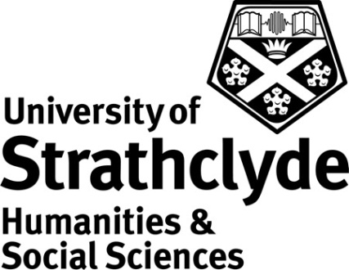

Centre for Lifelong Learning
Learn to Paint with Watercolours
Class Code: OS125 Credits: 10

Rationale

This class is designed to add a new strand of study to replace the class ‘Learn to Paint’ (OS642) and provide a basic foundation in the principles of working with watercolours.

Students who have previously taken the ‘Learn to Paint’ class which focuses on watercolours would not be able to gain credit again for this new class but should they choose to take ‘Learn to Paint using Acrylics’ they would be able to gain academic credit (upon successful completion).

Learning Outcomes
By the end of the class students should be able to:

- Demonstrate a knowledge of the properties of watercolour paints
- Discuss the basic elements of colour theory in the mixing of watercolour paints
- Demonstrate the use of tone and colour in relation to still life and landscape painting
- Demonstrate a technical grasp of the qualities of watercolour paints by painting still life and landscape paintings proficiently
- Demonstrate painting in layers
- Demonstrate the bleeding of colours
- Demonstrate textural marks

These outcomes have been designed to align closely with those of the classes ‘Learn to Paint in Acrylics’ and ‘Learn to Paint in Oils’ in order to ensure consistency across similar levels. The section below outlining the content and curriculum takes account of the considerable differences between handling and applying these various media to work.

Content and Curriculum

Participants are expected to have a good understanding of the basic principles of drawing as covered in Learn to Draw (OS641) or Stage 1 Drawing & Painting (OS401).

The following represents an overview of the main areas to be covered. It does not necessarily represent the order in which topics will be addressed, nor does it imply that equal time will be devoted to each topic.

- Watercolour materials and their specific qualities
- Introduction to mixing colours
- Exploring colour and tone
- Conveying texture
- Observation

Throughout the class, the work of various well-known artists will be used to encourage reflection on students’ work and to assist and stimulate discussion and reflection on technical problems and various techniques

Modes of Delivery

The class will be delivered through practical sessions involving a tutor-led brief and/or demonstration and will usually be offered over a 10 week period with 2 hour sessions each week. Exercises in class will be closely supervised and guided by the tutor. There will be group discussion of individual work to prepare students for peer assessment in later classes. There will also be scope for revision according to the needs of students as they present drawing projects.

Student Assessment

There are three elements to the assessment:
- 2 colour exercises completed in class (one to be discussed by the class as a group) (20%)
- 1 painting of a still life subject completed in class demonstrating use of techniques and skills learnt in class (40%)
- 1 landscape or figure painting completed in class demonstrating some skill in mixing colours (40%)

All elements of assessment must be submitted and deemed satisfactory by the tutor before the student can be recommended for the award of credit. A sample of work will be second marked prior to scrutiny by the Open Studies External Examiner.

Class Materials

Students are responsible for the purchase of their own materials and a list of materials suggested by the tutor will be supplied prior to the first class meeting.

References

Suggested book and web references include:

Peart, F (2007) 30-Minute Watercolours (London: Collins)
Wilcox, M (2002) Blue and Yellow Don’t Make Green (Bristol: Michael Wilcox)

http://www.artisancam.org.uk/home.php
http://www.getty.edu/education/
http://www.nsead.org/home/index.aspx

