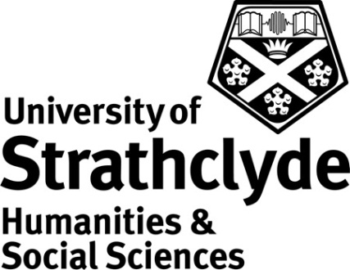

Centre for Lifelong Learning
Get to Grips with Pastels
Class Code: OS720 Credits: 10

Rationale
Get to Grips with Pastels is part of the Applied Arts Pathway within the Open Studies programme. The Open Studies programme provides flexible study options in a variety of subject areas allowing adult learners to accumulate credit towards initially an Open Studies Certificate (30 credits) and ultimately a Certificate of Higher Education in Lifelong Learning.

Applied Arts provision forms a significant part of Open Studies and continues to be a popular choice with students. It allows adults from a range of backgrounds to be introduced to a variety of art forms through practical activity. The ongoing success of the Open Studies Applied Arts programme is evidence that there is demand for both adult learners and students of the university (as elective or personal credit) to study creative and applied arts on a part-time basis.

Learning Outcomes
By the end of the class students should be able to:

- Demonstrate confidence in basic pastel drawing techniques (slipping, hatching, blending etc.)
- Demonstrate confidence in rendering still life drawings in colour accuracy
- Demonstrate confidence in composing pastel drawings and the ability to convey mood
- Demonstrate an understanding of proportion
- Demonstrate the use of observational skills

Content and Curriculum

The following list represents an overview of the areas to be covered in class meetings:

Basic life drawing with fruit/vegetables
Still life drawing with objects and fabric, applying ideas of composition
Landscape drawing with architecture
Landscape with trees
Basic figure drawing

Modes of Delivery

The class will be delivered through practical sessions involving a tutor-led brief and/or demonstration and will usually be offered over a 10 week period with 2 hour sessions each week. Exercises in class will be closely supervised and guided by the tutor. There will be group discussion of individual work to prepare students for peer assessment in later classes. There will also be scope for revision according to the needs of students as they present drawing projects.

Student Assessment

There are five elements to the assessment:
- Produce a sketch focussing on a specific subject presented by the tutor (using limited colours) (20%)
- Produce a still life study (20%)
- Produce a sustained still life study with fabric and objects (20%)
- Produce a landscape study (20%)
- Produce a landscape study (20%)

All elements of assessment must be submitted and deemed satisfactory by the tutor before the student can be recommended for the award of credit.

Class Materials

Students are responsible for the purchase of their own materials and a list of materials suggested by the tutor will be supplied prior to the first class meeting.

Recommended Reading

Creevy, B The Pastel Book (Watson-Guptill Publications Inc., U.S)
Lloyd, Christopher Edgar Degas: Drawings and Pastels (Thames and Hudson Ltd)
Martin, J The Encyclopaedia of Pastel Techniques (Headline Publishing Group) & (Search Press)
Wright, M Introduction to Pastels (The DK Art School)

